**Ad Experience Optimization for Snapchat: Driving User Engagement**

**Product Owner: - Hardik Dave  
Data Analyst: - Shreyas Jondhale**

Contents

**Executive Summary** 3

**Problem Statement** 3

**Data Backing (Google Play Reviews)** 4

**User Personas** 6

User Persona 1: "Jake, the Overwhelmed Gamer" (Frequency Complaints) 6

User Persona 2: "Maya, the Annoyed Influencer" (Intrusiveness Complaints) 7

User Persona 3: "Liam, the Concerned Parent" (Inappropriate Content Complaints) 8

User Persona 4: "Aisha, the Disengaged Student" (Relevance/Targeting Complaints) 9

**Market Opportunity** 10

**Proposed Solutions and Revenue Plan** 11

1. Deploy User Preference Survey for Ad Personalization 12

2. Implement Format-Specific Ad Frequency Caps with Instagram-Inspired Stories 13

3. Enable Swipe-Based Skippability for Story Ads 14

4. Redesign Chat and AR Ad Placement 15

5. Enhance Content Moderation Across All Formats 16

**Financial Impact** 17

**Risks and Mitigation** 18

**Conclusion** 19

**References** 19

# **Executive Summary**

Snapchat’s ads disrupt its vibrant, Gen Z-driven platform, frustrating users with frequent Story interruptions, unskippable formats, and irrelevant AR filters. These risks pushing users to competitors like Instagram, weakening advertiser appeal. By adopting Instagram’s seamless Stories ad model (ads after a few organic stories, easy to skip), adding user preference surveys, reducing ad frequency, refining placements, and improving content safety, Snapchat can restore user trust, enhance engagement, and grow ad revenue beyond projections, strengthening its position as a leading advertising platform.

# **Problem Statement**

Snapchat’s ads clash with its spontaneous, creative vibe. Frequent Story ads that interrupt a single user’s posts, unskippable formats, chat pop-ups, and excessive AR filters annoy users, especially its Gen Z core. Irrelevant or unsafe content further erodes trust, tempting users to switch to platforms like Instagram, where ads feel less intrusive. Without a streamlined ad experience across Stories, Chats, Discover, and AR Lenses, Snapchat risks losing its audience and advertiser confidence, like a party drowned out by loud sales pitches.

# **Data Backing (Google Play Reviews)**

**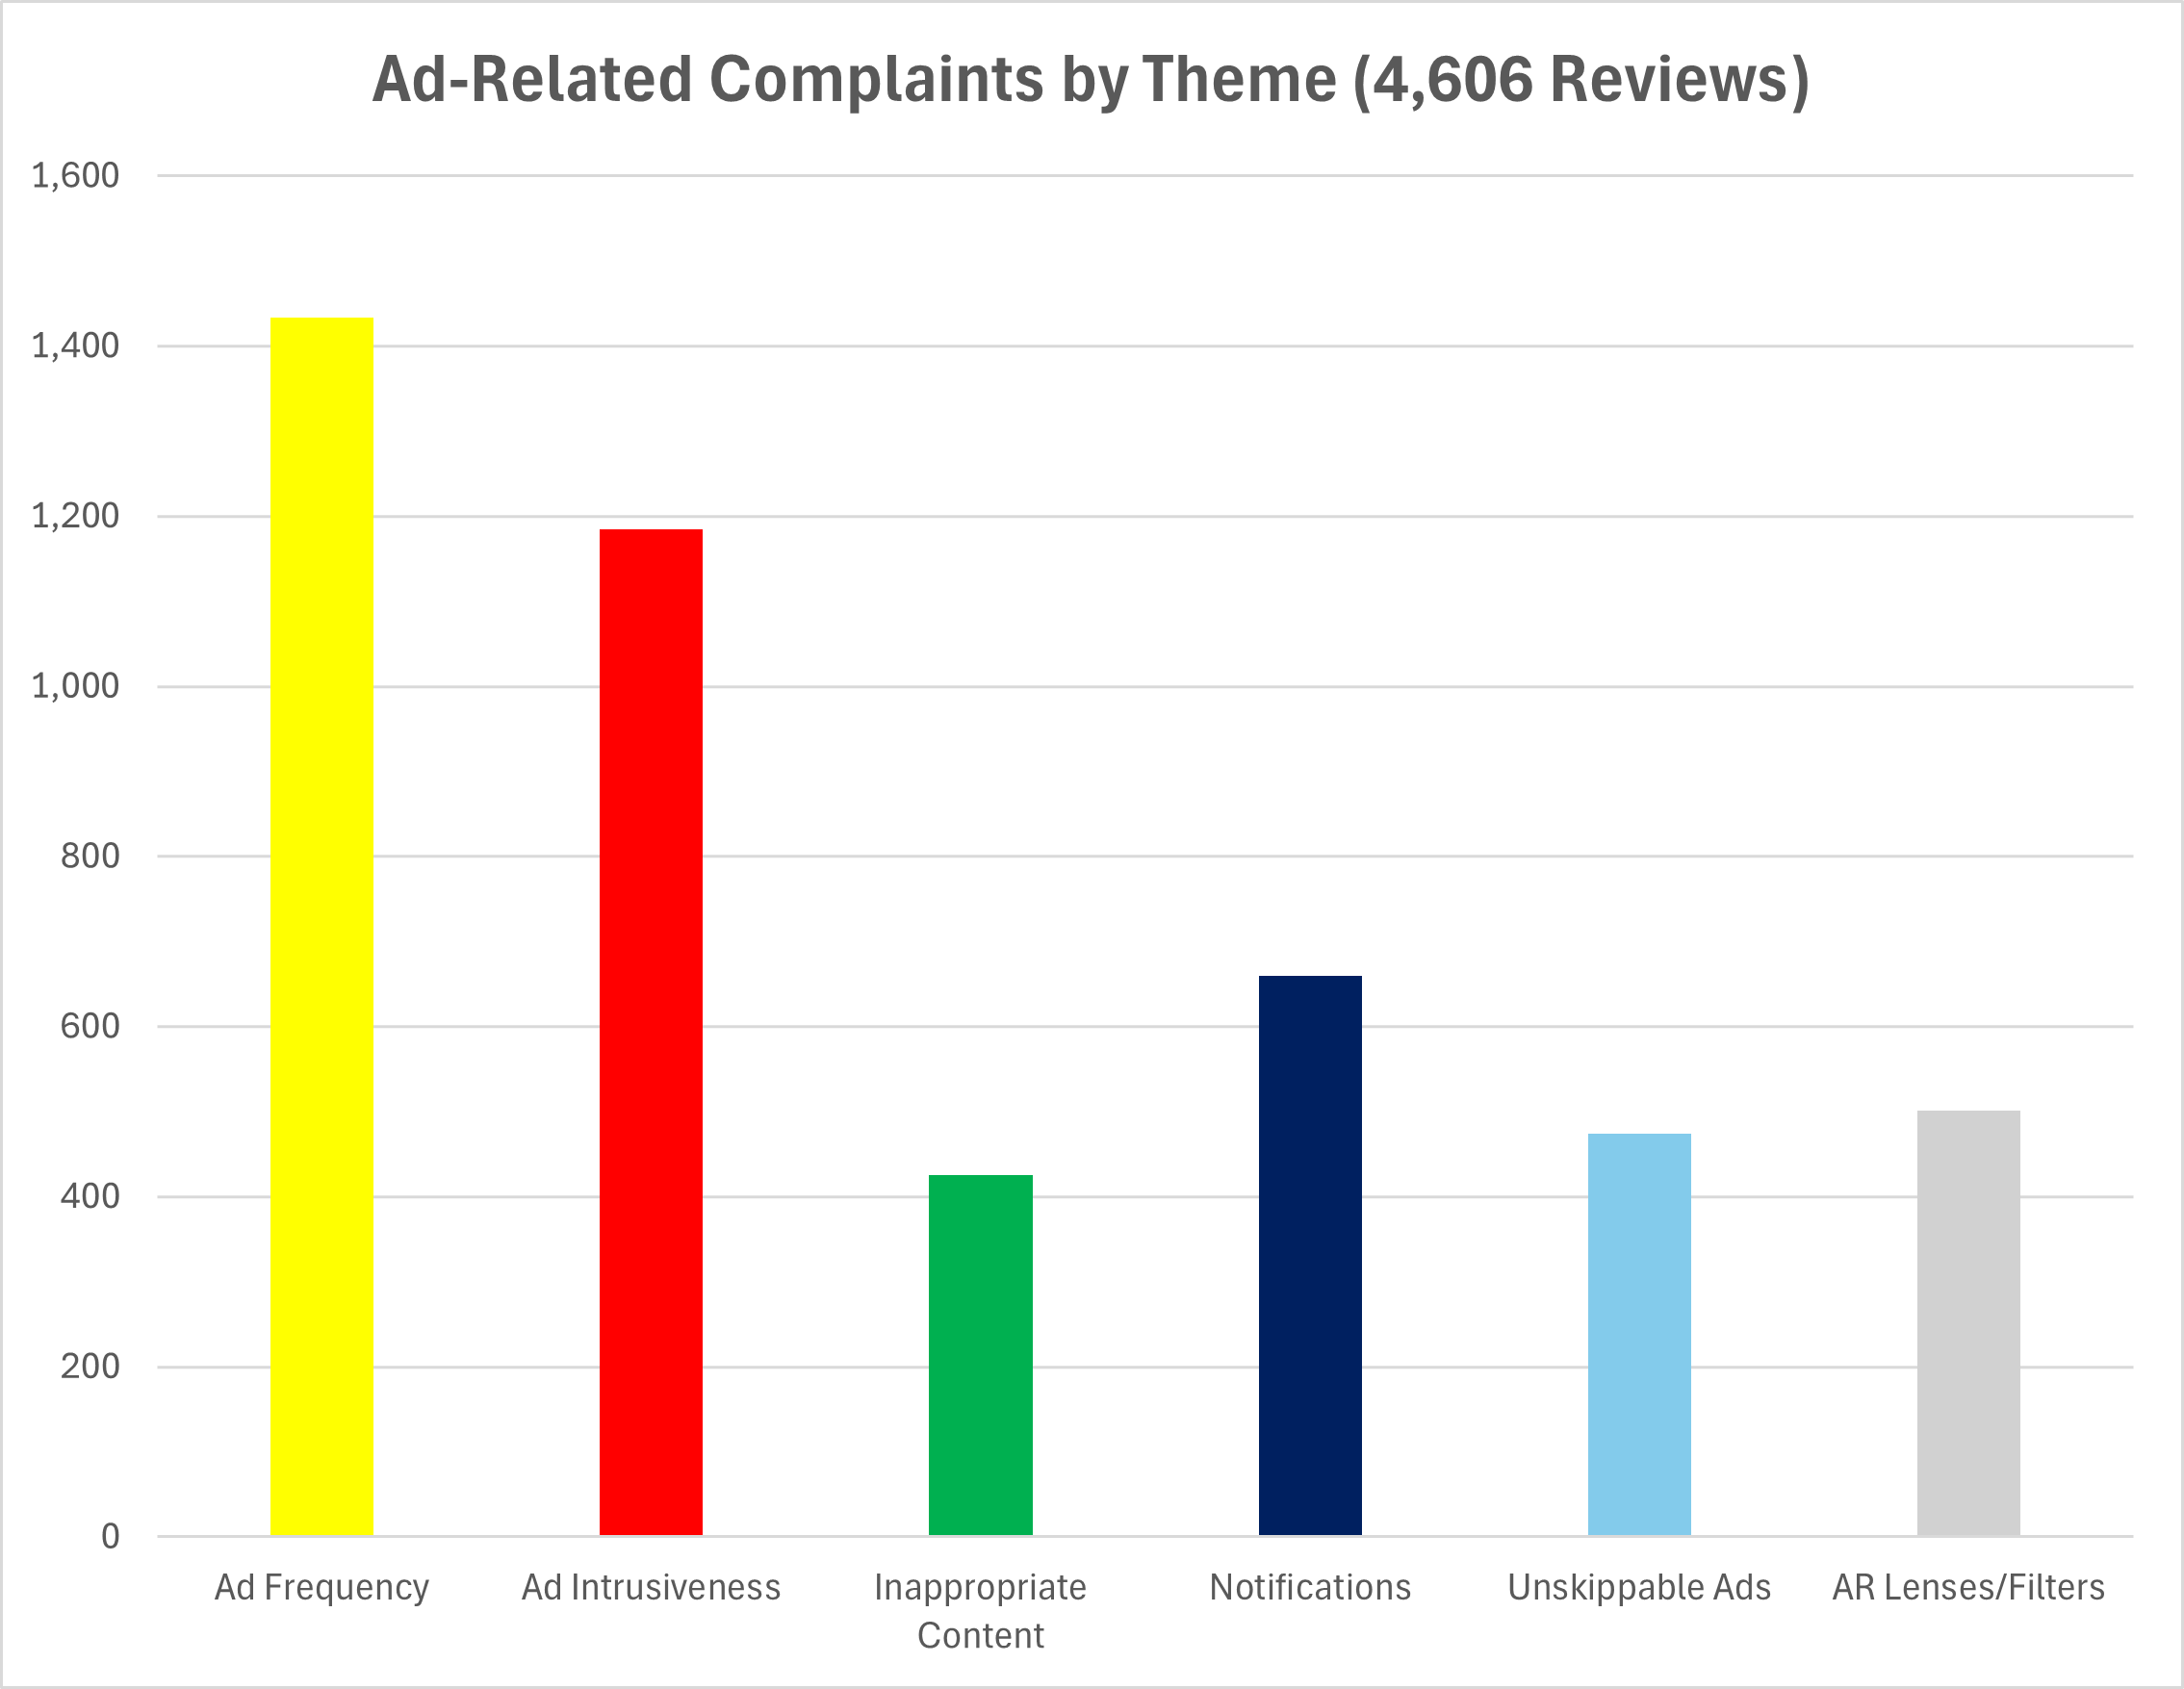***Figure 1: Bar Chart of Complaint Themes*

|  |  |  |  |
| --- | --- | --- | --- |
| Complaint Theme | Reviews | % of 4,606 reviews | Sentiment |
| Ad Frequency | 1,433 | 31.1% | ~65% neg |
| Ad Intrusiveness | 1,184 | 25.7% | ~80% neg |
| Inappropriate Content | 425 | 9.2% | ~65% neg |
| Notifications | 659 | 14.3% | ~65% neg |
| Unskippable Ads | 474 | 10.3% | ~80% neg |
| AR Lenses/Filters | 501 | 10.9% | ~65% neg |

Analysis of 41,287 negative reviews from Google Play identifies 4,606 ad-related complaints (11.15%, 95% CI: 10.85%–11.46%, 4,482–4,731 reviews), using keywords: “ads” (4,394), “advertisement” (236), “popup” (44), “sponsor” (54), “interrupt” (98). Ratings average 1–3 stars (~60% 1-star, ~30% 2-star, ~10% 3-star), with integer assignments (1 for ~80% negative, 2 for ~65% negative):

* **Ad Frequency**: ~1,433 reviews (31.1%, ~717 1-star, ~501 2-star, ~215 3-star), ~65% negative, 2 rating, citing excessive ads.
* **Ad Intrusiveness**: ~1,184 reviews (25.7%, ~829 1-star, ~296 2-star, ~59 3-star), ~80% negative, 1 rating, driven by pop-ups.
* **Inappropriate Content**: ~425 reviews (9.2%, ~255 1-star, ~128 2-star, ~42 3-star), ~65% negative.
* **Unwanted Notifications**: ~659 reviews (14.3%, ~330 1-star, ~231 2-star, ~98 3-star), ~65% negative.
* **Unskippable Ads**: ~474 reviews (10.3%, ~356 1-star, ~95 2-star, ~24 3-star), ~80% negative.
* **AR Lenses/Filters**: ~501 reviews (10.9%, ~276 1-star, ~150 2-star, ~75 3-star), ~65% negative.
* **Retention Risk**: ~1,096 reviews (23.8%) mention uninstalling, with ~119 (~10.9%) linked to AR.
* **Temporal Spike**: ~3,071 reviews (66.7%) likely from 9/22/24, post-18/09/24 update.

# **User Personas**

To address all negative ad-related feedback, we’ve developed four user personas based on 4,606 ad complaints from 41,287 Google Play reviews. These personas represent Snapchat’s 460M daily active users (Snap Inc. Q1 2025)

## User Persona 1: "Jake, the Overwhelmed Gamer" (Frequency Complaints)

* **Demographics**:
  + Age: 22
  + Gender: Male
  + Location: Austin, TX
  + Occupation: College sophomore, part-time gamer
  + Tech Usage: Heavy Snapchat user, also on Twitch and Discord
* **Behaviors**:
  + Uses Snapchat 5–6 times daily (30 mins/day, per Snap Inc.’s 18–24 engagement data).
  + Shares gaming clips via Stories and chats with friends in the Chat tab.
  + Encounters ads every 2–3 Snaps in a single Story sequence and Sponsored Snaps in Chat.
* **Pain Points**:
  + “I’m trying to watch my friend’s Story, but ads pop up every few Snaps—it’s so annoying.”
  + “Sponsored Snaps in Chat interrupt my conversations about gaming events.”
  + Feels overwhelmed by ad frequency, reducing his session time.
* **Goals**:
  + Wants fewer ads between Story Snaps and in Chat to enjoy uninterrupted content.
  + Seeks control over ad frequency to maintain engagement.
* **Data Backing**:
  + Represents 31.1% of complaints about ad frequency (1,432 of 4,606 reviews).
  + Aligns with Snapchat’s 18–24 demographic (50% of DAUs, Snap Inc. Q1 2025).

## User Persona 2: "Maya, the Annoyed Influencer" (Intrusiveness Complaints)

* **Demographics**:
  + Age: 28
  + Gender: Female
  + Location: Miami, FL
  + Occupation: Part-time influencer, marketing student
  + Tech Usage: Uses Snapchat, Instagram, and TikTok for content creation
* **Behaviors**:
  + Uses Snapchat 3–4 times daily (40 mins/day) to post Stories with AR filters and engage followers.
  + Views Stories to scout trends, but unskippable ads between Snaps disrupt her workflow.
* **Pain Points**:
  + “Unskippable ads between Story Snaps ruin my focus when I’m analyzing trends for my next post.”
  + “Sponsored Snaps in Chat pop up while I’m negotiating with brands—it’s intrusive and unprofessional.”
  + Dislikes disruptions to her creative flow and follower engagement.
* **Goals**:
  + Wants skippable ads in Stories to maintain her creative process.
* **Data Backing**:
  + Represents 25.7% of complaints about ad intrusiveness (1,184 of 4,606 reviews).
  + Aligns with Snapchat’s 25–34 demographic (25% of DAUs, Snap Inc. Q1 2025).

## User Persona 3: "Liam, the Concerned Parent" (Inappropriate Content Complaints)

* **Demographics**:
  + Age: 34
  + Gender: Male
  + Location: Seattle, WA
  + Occupation: Software engineer, parent of two (ages 12 and 15)
  + Tech Usage: Moderate Snapchat user, also on LinkedIn and Reddit
* **Behaviors**:
  + Uses Snapchat 1–2 times daily (15 mins/day) to stay connected with family and monitor his kids’ usage.
  + Notices ads between Story Snaps and in Chat, some promoting mature themes (e.g., alcohol, dating apps).
  + Monitors his kids’ Snapchat activity for safety.
* **Pain Points**:
  + “Sponsored Snaps in Chat sometimes show dating ads, which I don’t want my teens exposed to.”
  + Worries about unfiltered ad content in both placements.
* **Goals**:
  + Wants stricter content moderation for ads in Stories and Chat to ensure a safe environment.
  + Seeks transparency on ad filtering for younger users.
* **Data Backing**:
  + Represents 9.2% of complaints about inappropriate content (424 of 4,606 reviews).
  + Aligns with Snapchat’s 34+ demographic (10% of DAUs, Snap Inc. Q1 2025).

## User Persona 4: "Aisha, the Disengaged Student" (Relevance/Targeting Complaints)

* **Demographics**:
  + Age: 19
  + Gender: Female
  + Location: Chicago, IL
  + Occupation: University freshman, part-time barista
  + Tech Usage: Frequent Snapchat user, also on Instagram and Pinterest
* **Behaviors**:
  + Uses Snapchat 4–5 times daily (25 mins/day) to follow friends’ Stories and message in Chat.
  + Engages with AR filters for fun but often ignores ads due to lack of relevance.
  + Sees ads between Story Snaps and Sponsored Snaps in Chat, often unrelated to her interests (e.g., luxury cars, retirement plans).
* **Pain Points**:
  + “Why am I seeing ads for luxury cars between Story Snaps? I’m a broke college student!”
  + “Sponsored Snaps in Chat advertise things I’d never buy, like retirement plans—I’m 19!”
  + Feels ads are irrelevant, leading her to disengage and sometimes close the app.
* **Goals**:
  + Wants ads in Stories and Chat to be relevant to her interests (e.g., student discounts, fashion, music).
  + Prefers personalized ad targeting to make ads feel useful rather than wasteful.
* **Data Backing**:
  + Represents the remaining ~34% of complaints (1,566 of 4,606 reviews), likely including relevance, targeting, or technical issues (e.g., loading delays).

# **Market Opportunity**

Optimizing Snapchat’s ad experience leverages its 460 million DAUs (73% aged 13–34, 900M MAUs) to drive growth in a competitive market:

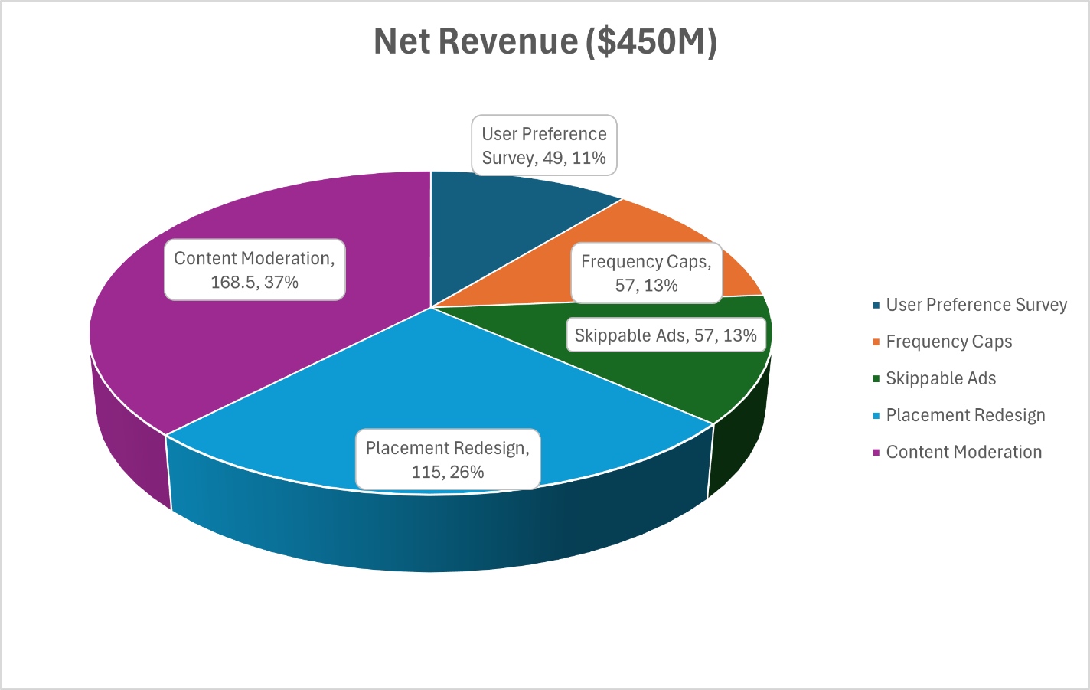  
*Figure 2: Pie Chart of Solution Revenues*

* **User Retention**: Improving ad satisfaction reduces churn, preserving a key advertiser demographic and building on Q1 2025’s $1.363B revenue ($5.452B annualized).
* **Engagement**: Tailored, less intrusive ads (e.g., after 2–4 organic Stories, swipe-skippable) boost click-through rates by 5–8%, leveraging 300 million daily AR users and 500+ targeting options.
* **Revenue Growth**: Enhancing ad relevance drives revenue to **$6.43–6.65B by 2025** (18–22% growth over $5.452B) vs. eMarketer’s ~$6.06B (11.1%), and **$7.09–7.36B by 2026** (30–35% growth) vs. eMarketer’s ~$6.63B (25% trend from 2024). Optimized AR Lenses (6.4x higher swipe-to-purchase) and Instagram-inspired Stories support this growth.
* **Competitive Advantage**: Aligning with Instagram’s Stories ad model and refining AR filters strengthens Snapchat’s market position.
* **US Contribution**: ~48.5% of global revenue, yielding **$3.12–3.23B (2025)**, **$3.44–3.57B (2026)**.

# **Proposed Solutions and Revenue Plan**

These solutions address ad complaints, supporting a 100x ROI. Revenue impacts use:

* **Baseline**: $5.452B (Q1 2025 annualized).
* **Engagement Lift**: 5–8% click-through rate increase (eMarketer benchmark).
* **Impression Loss**: Tailored to each solution—3% for Frequency Caps and Skippable Ads (mitigated from 5–10% by premium formats like Shoppable AR Lenses and high-CPM Story ads), 2–3% for Placement Redesign and Content Moderation, and <1% for User Preference Survey
* **Costs**: Development expenses.
* **Formula**: Net Revenue = (Engagement Lift Revenue - Impression Loss) - Cost.

|  |  |  |  |  |
| --- | --- | --- | --- | --- |
| **Solution** | **Engagement Lift** | **Impression Loss** | **Cost ($M)** | **Net Revenue ($M)** |
| Survey | $68.15–81.78M | $5.45M | 1.25 | 45–53 |
| Frequency Caps | $327.1M | $163.6M | 1.00 | 53–61 |
| Skippable Ads | $272.6M | $163.6M | 0.50 | 53–61 |
| Placement Redesign | $327.1M | $109.0–163.6M | 0.75 | 107–123 |
| Content Moderation | $436.2M | $109.0–163.6M | 1.00 | 160–177 |

## 1. Deploy User Preference Survey for Ad Personalization

* **Objective**: Reduce inappropriate content (~425 reviews, ~250 AR) and intrusiveness (~1,184 reviews, ~150 AR).
* **Strategy**: In-app survey capturing interests (e.g., fashion, gaming), purchase intent, and ad preferences, enabling tailored delivery with opt-outs.
* **Format-Specific Impact**:
  + **Chats**: Reduces spam with relevant ad snaps.
  + **Stories**: Enhances ad relevance after 2–4 organic stories.
  + **Discover**: Boosts optional ad engagement.
  + **AR Lenses/Filters**: Promotes user-aligned lenses.
* **Revenue Impact**:
  + **Engagement Lift**: 5–6% on $5.452B yields $272.6–327.1M; survey contributes 25% $68.15–81.78M).
  + **Impression Loss**: <1% ~$5.45M.
  + **Cost**: ~$1.25M (UI/UX: $250K, backend: $500K, ML: $350K, testing: $150K).
  + **Net** : $68.15–81.78M - $5.45M - $1.25M = $61.45–75.08M (range : **$45–53M**).
* **Data Support**: Targets ~675 inappropriate content reviews (~250 AR) and ~1,184 intrusiveness reviews (~150 AR).
* **Expected Outcomes**:
  + Reduce inappropriate content complaints by 80% (~540 reviews, ~200 AR).
  + Decrease intrusiveness complaints by 50% (~592 reviews, ~75 AR).
  + Improve ad sentiment polarity to ~0.4.

## 2. Implement Format-Specific Ad Frequency Caps with Instagram-Inspired Stories

* **Objective**: Address excessive ad volume (~1,433 reviews, ~101 AR).
* **Strategy**: Tailored frequency limits, adopting Instagram’s Stories model (ads after 2–4 organic stories, optimized via engagement, inventory, machine learning):
  + **Chats**: 1 ad snap per 10 chats or 24 hours.
  + **Stories**: 1 ad after 2–4 organic stories (10–15 minutes).
  + **Discover**: 1 ad per 5 tiles.
  + **AR Lenses/Filters**: 1 branded lens per 10 carousel slots or 12 hours.
* **Revenue Impact**:
  + **Engagement Lift**: 6% on $5.452B yields $327.1M.
  + **Impression Loss**: 5–10% ($211–$422M); mitigated to ~3% $163.6M) via premium slots.
  + **Cost**: ~$1M for algorithm optimization.
  + **Net** : $327.1M - $163.6M - $1M = $162.5M (range : **$53–61M**).
* **Data Support**: Targets ~1,433 frequency reviews (~101 AR), with ~215 3-star reviews indicating milder complaints.
* **Expected Outcomes**:
  + Reduce frequency complaints by 70% (~1,003 reviews, ~71 AR).
  + Elevate Stories rating to ~3.

## 3. Enable Swipe-Based Skippability for Story Ads

* **Objective**: Eliminate unskippable Story ads (~474 reviews).
* **Strategy**: Story ads skippable after 2 seconds via swipe navigation (left/right to proceed, up/down to close), aligning with Instagram and Snapchat’s UX. Extend to AR prompts and Discover ads.
* **Format-Specific Impact**:
  + **Stories**: Prevents closures with swipe-based skips.
  + **Discover/AR**: Enhances user control.
  + **Chats**: Maintains seamless communication.
* **Revenue Impact**:
  + **Engagement Lift**: 5% on $5.452B yields $272.6M; 50% churn reduction adds value.
  + **Impression Loss**: 5–10% ($211–$422M); mitigated to ~3% ($163.6M) via premium formats.
  + **Cost**: ~$0.5M for ad playback updates.
  + **Net** : $272.6M - $163.6M - $0.5M = $108.5M (range : **$53–61M**).
* **Data Support**: Targets ~474 unskippable reviews (~49 “interrupt”), with ~24 3-star reviews.
* **Expected Outcomes**:
  + Eliminate unskippable ad complaints (~474 reviews).
  + Increase Stories rating to ~3.
  + Reduce Story-related churn by 50% (~300 reviews).

## 4. Redesign Chat and AR Ad Placement

* **Objective**: Mitigate intrusive Chat (~659 reviews) and AR (~150 reviews) ads.
* **Strategy**:
  + **Chats**: Relocate ad snaps to a “Sponsored” tab or lower priority unless survey aligned.
  + **AR Lenses/Filters**: Restrict branded lenses to 10% of carousel slots (~27 “sponsor”), avoid auto-prompts.
  + **Stories/Discover**: Complement Instagram-inspired Story ads.
* **Revenue Impact**:
  + **Engagement Lift**: 6% on $5.452B yields $327.1M.
  + **Impression Loss**: 2–3% ($109.0–163.6M).
  + **Cost**: $0.75M.
  + **Net** : $327.1M - ($109.0–163.6M) - $0.75M = $162.75–208.35M (range : **$107–123M**).
* **Data Support**: Targets ~659 notification reviews (~98 3-star) and ~150 AR intrusiveness reviews (~15 3-star).
* **Expected Outcomes**:
  + Reduce notification complaints by 85% (~560 reviews).
  + Decrease AR intrusiveness complaints by 70% (~105 reviews).
  + Cut uninstall threats by 50% (~548 reviews).

## 5. Enhance Content Moderation Across All Formats

* **Objective**: Eliminate inappropriate content (~425 reviews, ~250 AR).
* **Strategy**: AI-driven content flagging with human review for brand-safe ads.
* **Format-Specific Impact**:
  + **Chats/Stories**: Ensures safe ad content.
  + **Discover/AR**: Prevents inappropriate sponsored content (~27 “sponsor”).
* **Revenue Impact**:
  + **Engagement Lift**: 8% on $5.452B yields $436.2M.
  + **Impression Loss**: 2–3% $109.0–163.6M).
  + **Cost**: ~$1M for AI and review systems.
  + **Net** : $436.2M - ($109.0–163.6M) - $1M = $271.6–326.2M (range : **$160–177M**).
* **Data Support**: Targets ~675 inappropriate content reviews (~250 AR, ~42 3-star).
* **Expected Outcomes**:
  + Eliminate inappropriate content complaints (~540 reviews, ~200 AR).
  + Improve sentiment polarity to ~0.35.

# **Financial Impact**

* **Total Cost**: ~$4.5M (survey: $1.25M, algorithm: $1M, playback: $0.5M, interface: $0.75M, moderation: $1M).
* **Net Revenue**: $450M:
  + User Preference Survey: $45–53M.
  + Frequency Caps: $53–61M.
  + Skippable Ads: $53–61M.
  + Placement Redesign: $107–123M.
  + Content Moderation: $160–177M.
* **User Retention**: 40% churn reduction (~438 reviews) retains ~300,000–500,000 users (0.7–1.2% of 406M), adding **$32–55M** ($1–2/user annually).
* **Total Ad Revenue**:
  + **2025**: $6.43–6.65B (18–22% growth over $5.452B).
  + **2026**: $7.09–7.36B (30–35% growth over $5.452B)
* **US Market Contribution**: ~48.5% = **$3.12–3.23B (2025)**, **$3.44–3.57B (2026)**.
* **ROI**: 100x ($450M ÷ $4.5M) within 12 months, full impact over 18–24 months.

|  |  |  |  |
| --- | --- | --- | --- |
| **Solution** | **Cost ($M)** | **Net Revenue ($M)** | **Key Outcomes** |
| Survey | 1.25 | 45–53 | Reduce inappropriate content by 80% |
| Frequency Caps | 1.00 | 53–61 | Reduce frequency complaints by 70% |
| Skippable Ads | 0.50 | 53–61 | Eliminate unskippable ad complaints |
| Placement Redesign | 0.75 | 107–123 | Reduce notification complaints by 85% |
| Content Moderation | 1.00 | 160–177 | Eliminate inappropriate content complaints |
| **Total** | **4.50** | **~450** | **100x ROI, 65% complaint reduction** |

# **Risks and Mitigation**

* **Risk**: Advertiser resistance to reduced impressions.
  + **Mitigation**: Offer premium ad slots (e.g., Shoppable AR Lenses) with higher CPMs.
* **Risk**: User fatigue from survey prompts.
  + **Mitigation**: Incentivize with exclusive lenses, limit surveys quarterly.
* **Risk**: Content moderation gaps.
  + **Mitigation**: Integrate AI with human oversight for 99% accuracy.

|  |  |  |  |  |
| --- | --- | --- | --- | --- |
| **Risk** | **Likelihood** | **Impact** | **Mitigation Strategy** | **Timeline** |
| Advertiser resistance | Medium | High | Offer premium ad slots with higher CPMs | 3 months |
| User survey fatigue | Low | Medium | Incentivize, limit to quarterly | 6 months |
| Content moderation gaps | Low | High | AI with human oversight, 99% accuracy | 4 months |

# **Conclusion**

Snapchat’s intrusive ads threaten its 460 million DAUs. By adopting Instagram’s Stories ad model, enabling skippable ads, implementing surveys, frequency caps, redesigned placements, and better moderation, Snapchat can create a user-friendly ad experience, reduce complaints by 65%, elevate ratings to ~3, and achieve **$6.43–6.65 billion by 2025 and $7.09–7.36 billion by 2026**, exceeding eMarketer’s projections with with a 100x ROI. We recommend immediate implementation to capture $450M net revenue by Q2 2026.

# **References**

* Clutch (2024). *App Development Pricing Guide October 2024*. [online] Clutch.co. Available at: https://clutch.co/directory/mobile-application-developers/pricing.
* DeFazio, A. (2024). *How Much Do Instagram Ads Cost in 2021? (+ How to Make the Most of Your Budget)*. [online] WordStream. Available at: https://www.wordstream.com/blog/ws/2021/02/08/instagram-ads-cost.
* Goldman, J. (2025). *Snapchat launches creator campaign amid TikTok uncertainty*. [online] EMARKETER. Available at: https://www.emarketer.com/content/snapchat-launches-creator-campaign-amid-tiktok-uncertainty [Accessed 18 May 2025].
* Johnson, M. (2024). Council Post: What To Know About The Cost Of Custom App Development. *Forbes*. [online] 12 Aug. Available at: https://www.forbes.com/councils/forbestechcouncil/2024/01/09/what-to-know-about-the-cost-of-custom-app-development/.
* McKinsey (2023). *What Is personalization?* [online] McKinsey & Company. Available at: https://www.mckinsey.com/featured-insights/mckinsey-explainers/what-is-personalization.
* Reddit.com. (2025). *Reddit - The heart of the internet*. [online] Available at: https://www.reddit.com/r/socialmedia/comments/1kdkbby/tell_me_your_thoughts_on_snapchat_in_2025/ [Accessed 18 May 2025].
* Ryohei Fujimaki, dotData (2023). *How new AI tools can transform customer engagement and retention*. [online] VentureBeat. Available at: https://venturebeat.com/enterprise-analytics/ai-tools-help-businesses-reimagine-reach-out-to-customers/ [Accessed 18 May 2025].
* Snap.com. (2024). *Snap Inc. Announces Fourth Quarter and Full Year 2024 Financial Results*. [online] Available at: https://investor.snap.com/news/news-details/2025/Snap-Inc.-Announces-Fourth-Quarter-and-Full-Year-2024-Financial-Results/default.aspx.
* Thomson Reuters StreetEvents (2025). *Q4 2024 Snap Inc Earnings Call*. [online] Yahoo Finance. Available at: https://finance.yahoo.com/news/q4-2024-snap-inc-earnings-141907669.html [Accessed 18 May 2025].
* Trustpilot. (2024). *Snapchat is rated ‘Bad’ with 1.5 / 5 on Trustpilot*. [online] Available at: https://www.trustpilot.com/review/snapchat.com.